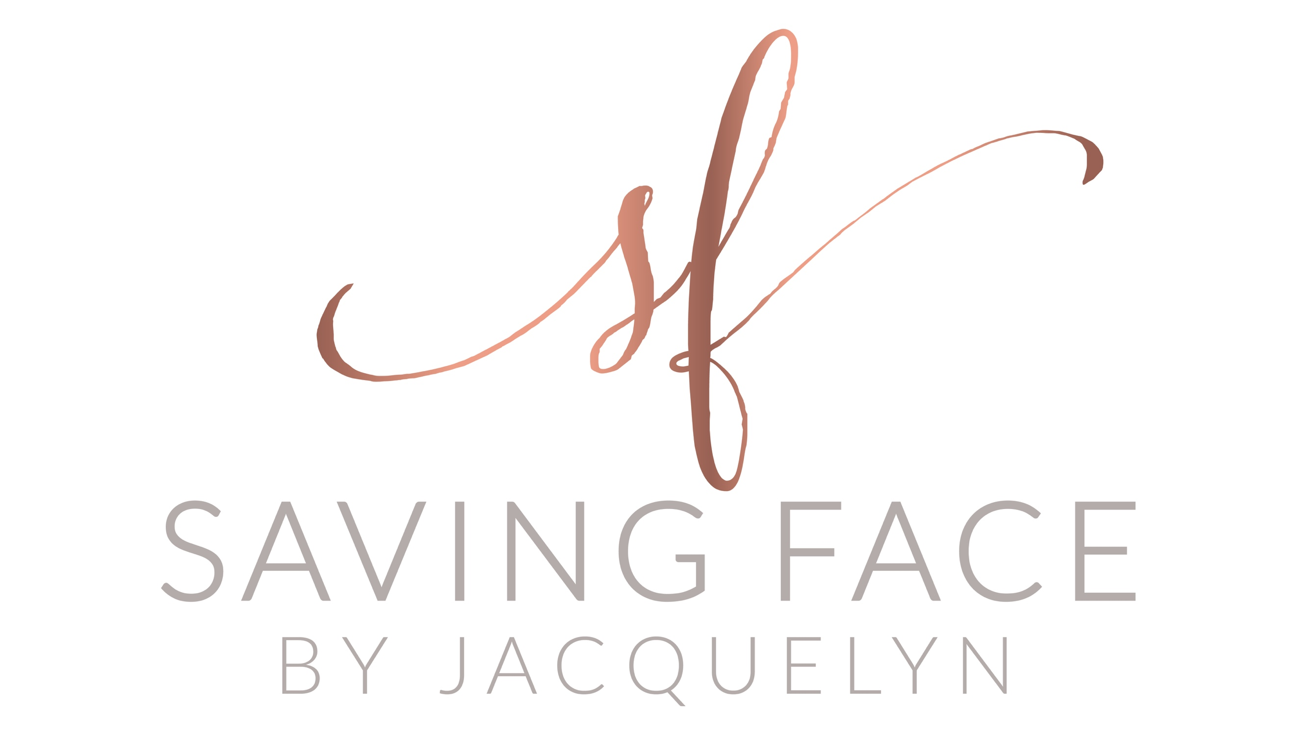
5200 Park Road
Suite 213F
Charlotte, NC 28209
207-263-4803

Happy (almost) Labor Day!
I think, as the holiday is literally an observance of workers in America, it is high time we honored that for ourselves.
And that means....
The spa will be having Labor Day specials!
You should be able to actually enjoy a well-deserved break and treat yourself! I encourage it and that's why I am offering:
- $10 OFF any skincare product bought between tomorrow (Tuesday, August 27th) and the end of the following week (Saturday, September 7th).
*please order through me via email, phone, or text so I can apply the discount for you*

And.....

- A special package price ($25 OFF) two facials when bought together between Tuesday, August 27th and Saturday, September 7th.
*these facials do not have to used during that time, just purchased together then..... you can even use one in the form of a giftcard for someone special!*

