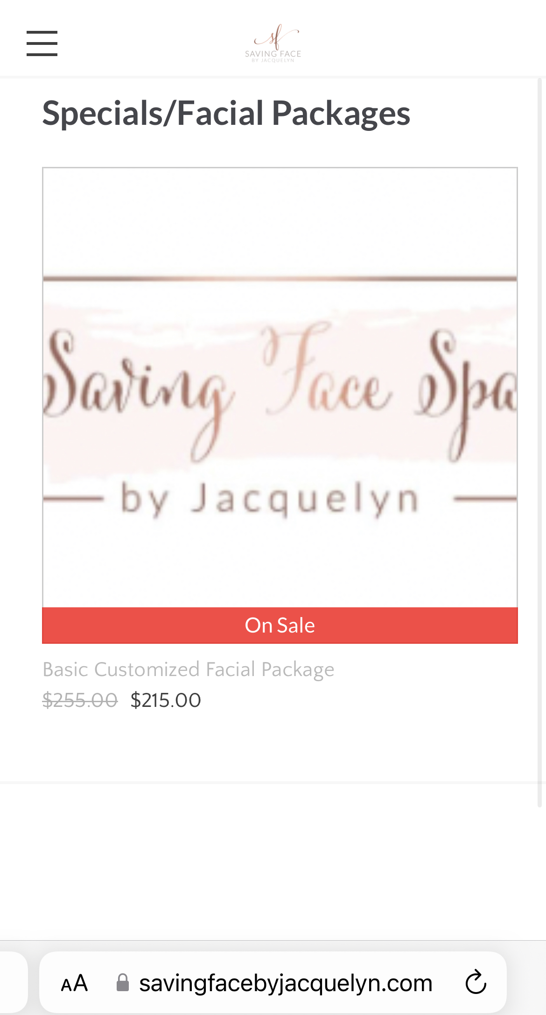

***Go to the Products page on our website and view the Basic Customized Facial Package to snag a deal!***