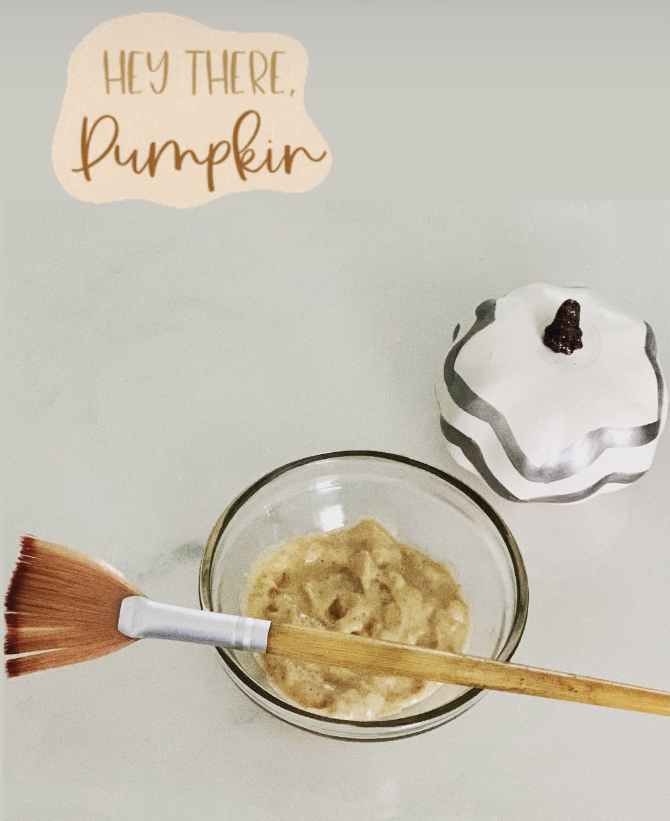

Pumpkin Facials are BACK for the Fall!

Book for the month of November
for the special price
of only $75!

